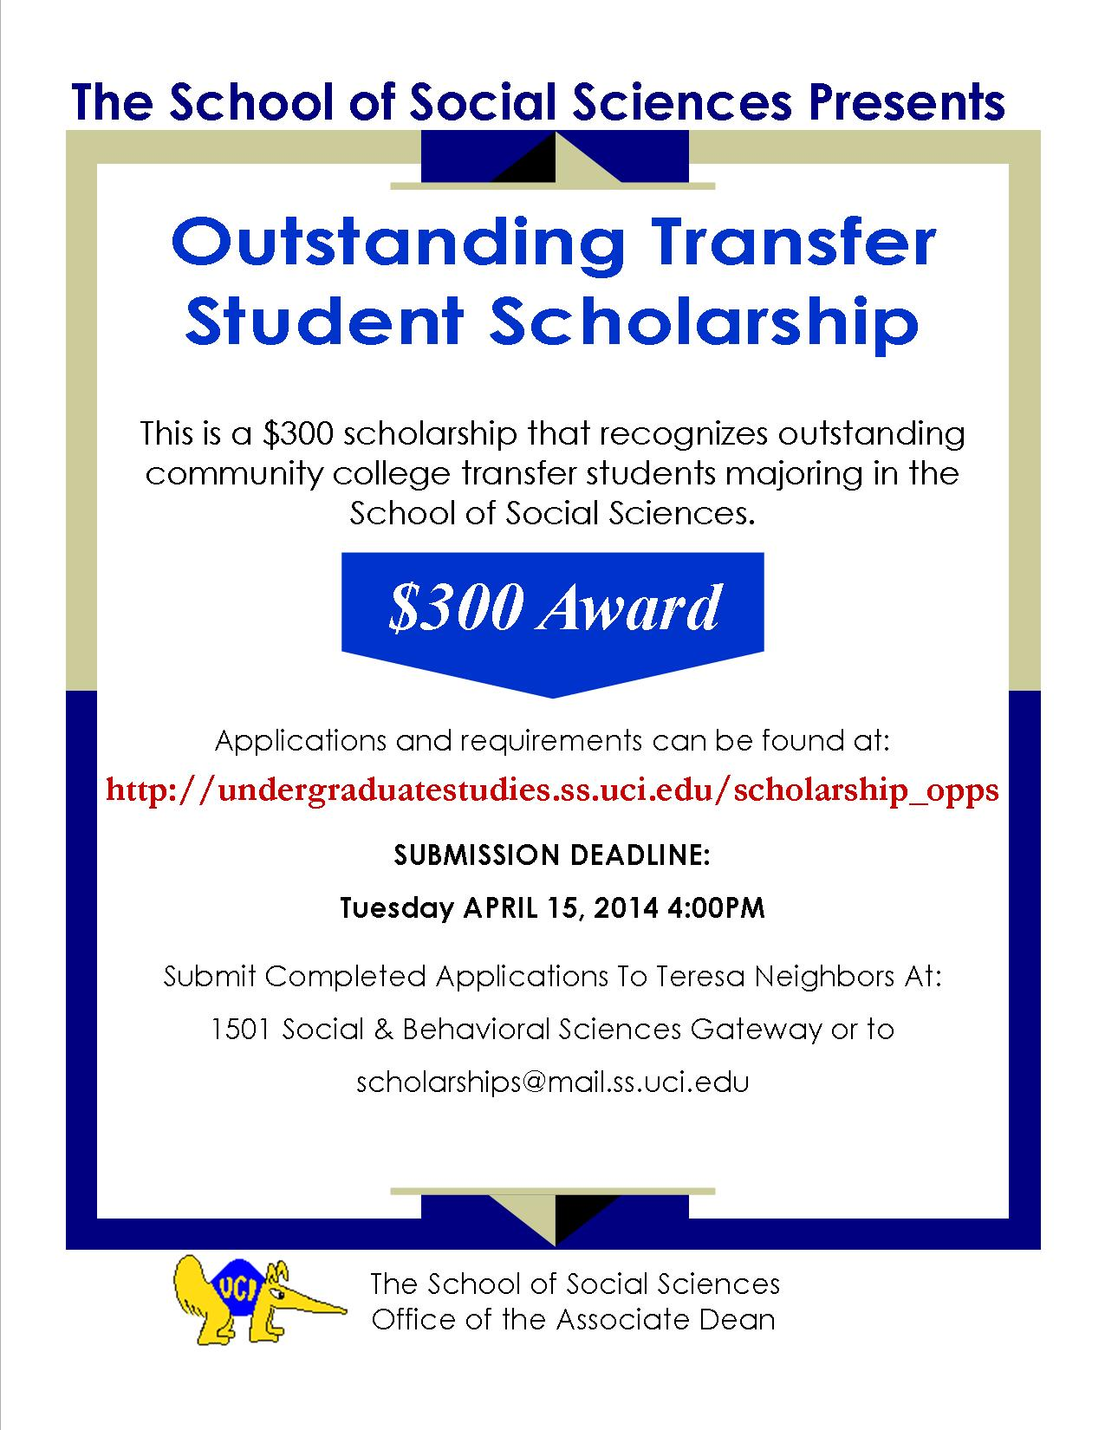
Application Information
Name: | Major(s):
UCI Student ID#: | GPA: | Gender: Male Female
Local Address: | Expected Year of Graduation:
City: | State: | Zip Code:
UCI E-mail: | Phone Number: ( ) -
Are you receiving Financial Aid? Yes No | Are you the first member of your immediate family to attend a four-year college or university? Yes No
List all awards/recognitions you have received during your time at UC Irvine:

List community service involvement and extra-curricular activities on campus:

List all research activities (UROP, Senior Thesis) and the name(s) of your faculty advisors:

Please list two faculty members who are familiar with your academic work at UC Irvine.
Faculty Reference 1
Name: | UCI E-mail:
Title: | Office:
Department: | Office Telephone Number: ( ) -

Faculty Reference 2
Name: | UCI E-mail:
Title: | Office:
Department: | Office Telephone Number: ( ) -

Please forward the following recommendation form link to the two faculty members identified above: http://www.socsci.uci.edu/~tneighbo/FacRec.doc
Faculty may submit either a letter or a completed form. Recommendations can be emailed to Teresa Neighbors at scholarships@mail.ss.uci.edu or submitted in person at 1501 Social & Behavioral Sciences Gateway.
Scholarship Information
To be eligible for any scholarship, the applicant must be an undergraduate majoring in the School of Social Sciences and must be a U.S. citizen or Permanent Resident.

School of Social Sciences Outstanding Transfer Student Scholarship Award amount: $300.00
This scholarship recognizes outstanding transfer students.

Requirements:
- Scholarship is limited to community college transfer students with a minimum 3.0 GPA
- Must have completed a minimum of two quarters at UCI as an undergraduate majoring within the School of Social Sciences
- Applicants are to submit a personal statement that will describe how the scholarship funds will be used in pursuit of their educational goals
- CV/Resume (5 pages maximum)
- Two letters of recommendation required

Note: If you desire, you may choose to obtain Letters of Recommendation from persons other than those listed in “Faculty Reference” section above. Although letters will be accepted from non-faculty (ie: T.A.s or staff) it is highly recommended that you obtain your letters from regular faculty members. Provide your name and UCI identification number on all documents.

Deadline
Please submit your application electronically to Teresa Neighbors at scholarships@mail.ss.uci.edu
or in person at 1501 Social & Behavioral Sciences Gateway.

The deadline for scholarship submission is 4:00 p.m. Tuesday April 15, 2014.

Applicant Signature
Applicant Signature: | Date: / /
(Typed name will be accepted as signature) | mm dd yy

For Department Use Only
Received by: | Reviewed by:
Awarded?: Yes No | Date Submitted: | Award Date:
*All submitted application and attached documents become the sole property of the School of Social Sciences and will not be returned once received.

